# Brainstorm

**TIP**

You can select a sticky note and hit the pencil [switch to sketch] icon to start drawing!

### Before you collaborate

#### A little bit of preparation goes a long way with this session. Here’s what you need to do to get going.

##### 10 minutes

**1**

### Define your problem statement

#### What problem are you trying to solve? Frame your problem as a How Might We statement. This will be the focus of your brainstorm.

##### 5 minutes

**2**

### Brainstorm

#### Write down any ideas that come to mind that address your problem statement.

##### 10 minutes

**3**

### Group ideas

#### Take turns sharing your ideas while clustering similar or related notes as you go. In the last 10 minutes, give each cluster a sentence-like label. If a cluster is bigger than six sticky notes, try and see if you and break it up into smaller sub-groups.

##### 20 minutes

**4**

### Prioritize

#### Your team should all be on the same page about what's important moving forward. Place your ideas on this grid to determine which ideas are important and which are feasible.

**20 minutes**

### After you collaborate

You can export the mural as an image or pdf to share with members of your company who might find it helpful.

**Quick add-ons**

# & idea prioritization

**PROBLEM**

**How might we [your problem statement]?**

ALGORITHM

Use this template in your own brainstorming sessions so your team can unleash their imagination and start shaping concepts even if you're not sitting in the same room.

1. **Team gathering**

Define who should participate in the session and send an invite. Share relevant information or pre-work ahead.

1. **Set the goal**

Think about the problem you'll be focusing on solving in the brainstorming session.

1. **Learn how to use the facilitation tools**

Use the Facilitation Superpowers to run a happy and productive session.

**POTU GANGA MANOJ KUMAR**

LED is used to indicate the sensors condition

By using IOT devices to transfer measured data to the cloud.

By using the IOT devices, farmers can monitor the feld conditions from anywere.

To develop web application for user interface

**TIP**

Add customizable tags to sticky notes to make it easier to find, browse, organize, and categorize important ideas as themes within your mural.

Tracking and tracing of the product to meet the needs of the consumer to increase proft

If parameter reached a certain value it automatically ON the corresponding device

By using the IOT devices, farmers can monitor the feld conditions from anywere

To develop web application for user interface

To produce smart agricultural system and its expected to enhance efciency and productivity

To implement the IOT technology in agricultural feld

By using Soil moisture sensor to measure amount of water in the so

By using Soil nutrition sensor to measure soil nutrition

## 

By using IOT devices to transfer measured data to the cloud.

Establish reliable, secure and robust communication between cloud and farms

From moisture sensor output to control by the motor whether on/off condition

**HASHIM ASLAM**

## 

Interfacing farmer to through the mobile applications

Based on the presence of water in the well , for how many hours the motor will run and approximate land will be irrigated will be notifed to the user

Rain sensor is used to prevent immediately after a rainfall

From soil nutrition sensor output supply chain can be monitored

## 

To implement water level monitor to indicate the motor condition

Based on the climate ,the control is given to the user to control the water pumps

**AVULA SUNEEL**

## 

LED is used to indicate the sensors condition

The use of IOT devices to transfer the measured data to the cloud

by using solar energy to reduce amount of fuels

By using arduino to control automattically / manually

## 

To produce smart agricultural system and its expected to enhance efciency and productivity

Based on the climate ,the control is given to the user to control the water pumps

**CHEMUDUGUNTA AJAY KUMAR**

## 

Interfacing farmers/owners through web application

Using moisture sensor to measure soil moisture

Using anemometer to measure air speed

Tracking and tracing of the product to meet the needs of the consumer to increase profit

All the data aquired are transferred to IOT cloud using watson IOT platform

It can displayed in the interface

To develop web application for user interface

By using the IOT devices, farmers can monitor the feld conditions from anywere.

Write a program to combine all the sensors to see induvidual output through web application

Temperature sensor used to measure temperature..

LED is used to indicate the sensor is whether running condition or not

From soil nutrition sensor output supply chain can be monitored

To develop mobile application by user interface

All the data aquired are transferred to IOT cloud using watson IOT platform

1. **Share the mural**

**Share a view link** to the mural with stakeholders to keep them in the loop about the outcomes of the session.

1. **Export the mural**

Export a copy of the mural as a PNG or PDF to attach to emails, include in slides, or save in your drive.

**10 minutes** to prepare

**1 hour** to collaborate

**2-8 people** recommended

[**Open article**](https://support.mural.co/en/articles/2113740-facilitation-superpowers)

Based on the presence of water in the well , for how many hours the motor will run and approximate land will be irrigated will be notifed to the user

It can displayed in the interface

Tracking and tracing of the product to meet the needs of the consumer to increase proft

**Key rules of brainstorming**

Based on the climate ,the control is given to the user to control the water pumps

To run an smooth and productive session

All the data aquired are transferred to

IOT cloud

Tracking and tracing of the product to meet the

DATA AND INFORMATIONS

PREPLANNING

Establish reliable, secure and robust communication between cloud and farms

needs of the consumer to increase proft

It can displayed in the interface

### Keep moving forward

**Strategy blueprint**

Define the components of a new idea or strategy.

[**Open the template**](https://app.mural.co/template/e95f612a-f72a-4772-bc48-545aaa04e0c9/984865a6-0a96-4472-a48d-47639307b3ca)

**Customer experience journey map**

Understand customer needs, motivations, and

Stay in topic.

Using anemometer to measure air speed

From soil nutrition sensor output supply chain can be monitored

To implement the IOT technology in agricultural feld

Defer judgment.

Encourage wild ideas.

Listen to others.

### Importance

PREDICTIONS

If each of these tasks could get

Tracking and tracing of the product to meet the needs of the consumer to increase pro

To produce smart agricultural system and its expected to enhance efciency and productivity

Based on the climate ,the control is given to the user to control the water pumps

obstacles for an experience.

[**Open the template**](https://app.mural.co/template/b7114010-3a67-4d63-a51d-6f2cedc9633f/c1b465ab-57af-4624-8faf-ebb312edc0eb)

Rain sensor is used to prevent immediately after a rainfall

**Strengths, weaknesses, opportunities & threats**

Go for volume. If possible, be visual.

done without any difficulty or cost, which would have the most positive impact?

Identify strengths, weaknesses, opportunities, and threats (SWOT) to develop a plan.

By using IOT devices to transfer measured data to the cloud.

Based on the climate ,the control is given to the user to control the water pumps

LED is used to indicate the sensors condition

[**Open the template**](https://app.mural.co/template/6a062671-89ee-4b76-9409-2603d8b098be/ca270343-1d54-4952-9d8c-fbc303ffd0f2)

###### TIP

Participants can use their cursors to point at where sticky notes should go on the grid. The facilitator can confirm the spot by using the laser pointer holding the **H key** on the keyboard.

[**Share template feedback**](https://muralco.typeform.com/to/CiqaHVat?typeform-source=app.mural.co)

[**Share template feedback**](https://muralco.typeform.com/to/CiqaHVat?typeform-source=app.mural.co)

### Feasibility

Regardless of their importance, which tasks are more feasible than others? (Cost, time, effort, complexity, etc.)

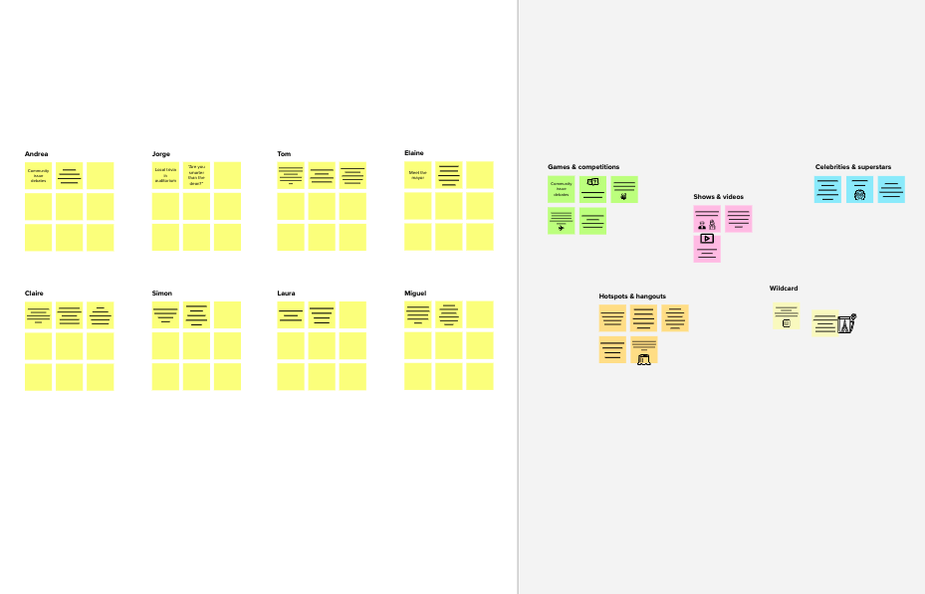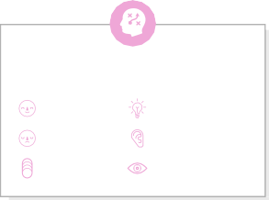

**Template**

**Need some inspiration?**

See a finished version of this template to kickstart your work.

[**Open example**](https://app.mural.co/template/e5a93b7b-49f2-48c9-afd7-a635d860eba6/93f1b98d-b2d2-4695-8e85-7e9c0d2fd9b9)